**NAME : Anish Patial  
UID : 22BCS15029**

**SECTION : Fl_Iot 601 ‘A’**

**Ap experiment 7**

1. [**Climbing Stairs**](https://leetcode.com/problems/climbing-stairs/)

class Solution {

public:

int climbStairs(int n) {

vector<int> dp(n + 1);

dp[0] = 1;

dp[1] = 1;

for (int i = 2; i <= n; ++i) {

dp[i] = dp[i - 1] + dp[i - 2];

}

return dp[n];

}

};

1. [**Jump Game**](https://leetcode.com/problems/jump-game/)

class Solution {

public:

bool canJump(vector<int>& nums) {

int i = 0;

for (int reach = 0; i < nums.size() && i <= reach; ++i)

reach = max(reach, i + nums[i]);

return i == nums.size();

}

};

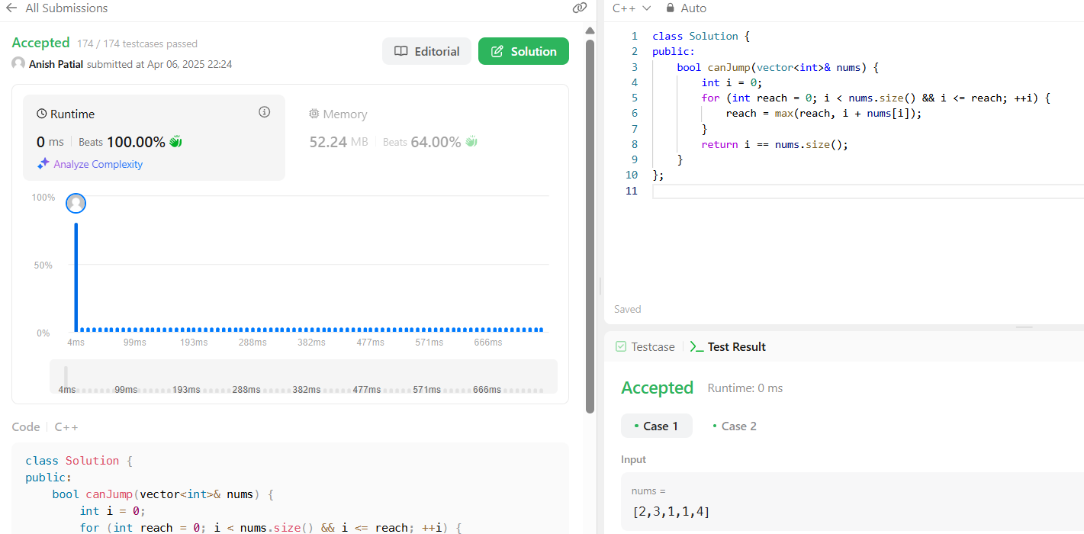

1. [**Maximum Product Subarray**](https://leetcode.com/problems/maximum-product-subarray/)

class Solution {

 public:

  int maxProduct(vector<int>& nums) {

    int ans = nums[0];

    int dpMin = nums[0];

    int dpMax = nums[0];

    for (int i = 1; i < nums.size(); ++i) {

      const int num = nums[i];

      const int prevMin = dpMin;

      const int prevMax = dpMax;

      if (num < 0) {

        dpMin = min(prevMax * num, num);

        dpMax = max(prevMin * num, num);

      } else {

        dpMin = min(prevMin * num, num);

        dpMax = max(prevMax * num, num);

      }

      ans = max(ans, dpMax);

    }

    return ans;

  }

};

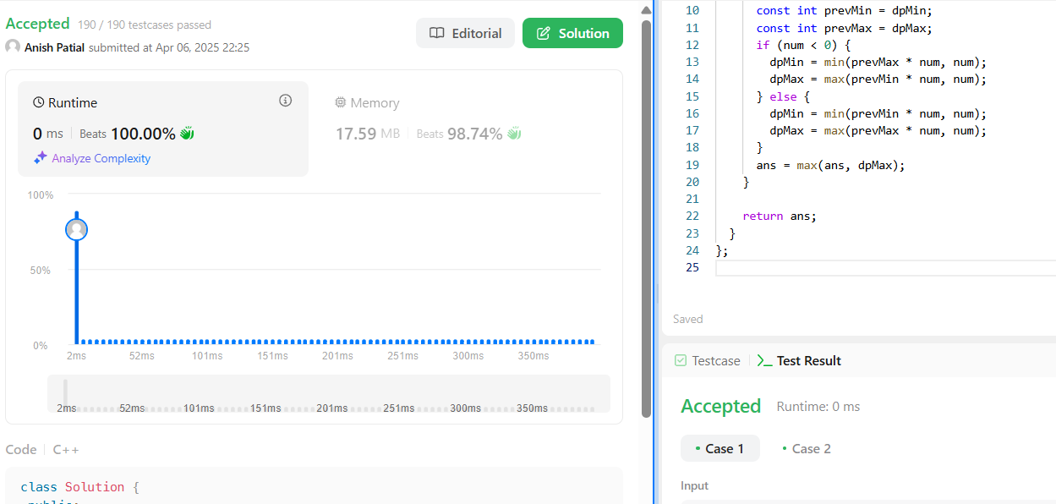

1. [**Perfect Squares**](https://leetcode.com/problems/perfect-squares/)

class Solution {

 public:

  int numSquares(int n) {

    vector<int> dp(n + 1, n);

    dp[0] = 0;

    dp[1] = 1;

    for (int i = 2; i <= n; ++i)

      for (int j = 1; j * j <= i; ++j)

        dp[i] = min(dp[i], dp[i - j * j] + 1);

    return dp[n];

  }

};

